PostgreSQL Exam Preparation III

Submit your solutions to the SoftUni Judge Contest.

Board Games

Emily has a passion for collecting and playing all sorts of board games. Her game collection has grown significantly over the years, and she is constantly on the lookout for new and exciting games to add to it.
As her collection grew, Emily found it increasingly challenging to keep track of all the games she owned. She realized that she needed a way to manage her collection more efficiently and decided to create a database that would store all the relevant information about her games.

Section 1. Data Definition Language (DDL) - (30 pts)
The following E/R Diagram of the Board Games database was created by Emily.
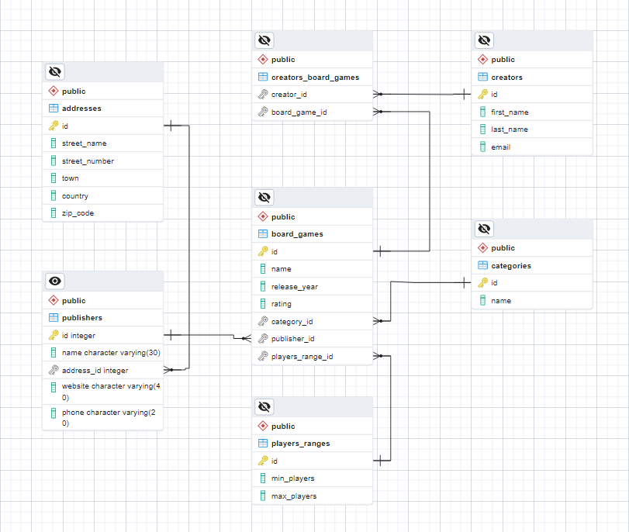
Assist Emily in setting up a PostgreSQL database called "board_games_db" which should include seven tables:
- "categories" - hold data about the name of each board game category;
- "addresses" - store information regarding the locations of board game publishers;
- "publishers" - contain information about the publishers of the board games;
- "players_ranges" - hold information about the minimum and maximum player counts for each game;
- "creators" - store data about the creators of the board games;
- "board_games" - contain information about each individual board game;
- "creators_board_games" - serves as a mapping table between the creators and board games.
Your first assignment is to create the database tables based on the provided models. Follow the given specifications to create the tables.

categories
Column Name | Data Type | Constraints
id | Integer from 0 to 2,147,483,647 | Primary Key, Unique table identification, Auto-increment
name | String up to 50 symbols | NULL is not allowed

addresses
Column Name | Data Type | Constraints
id | Integer from 0 to 2,147,483,647 | Primary Key, Unique table identification, Auto-increment
street_name | String up to 100 symbols | NULL is not allowed
street_number | Integer from 0 to 2,147,483,647 | NULL is not allowed, Must be a positive number
town | String up to 30 symbols | NULL is not allowed
country | String up to 50 symbols | NULL is not allowed
zip_code | Integer from 0 to 2,147,483,647 | NULL is not allowed, Must be a positive number

publishers
Column Name | Data Type | Constraints
id | Integer from 0 to 2,147,483,647 | Primary Key, Unique table identification, Auto-increment
name | String up to 30 symbols | NULL is not allowed.
address_id | Integer from 0 to 2,147,483,647 | Relationship with table addresses, Cascade Operations, NULL is not allowed
website | String up to 40 symbols | NULL is permitted
phone | String up to 20 symbols | NULL is permitted

players_ranges
Column Name | Data Type | Constraints
id | Integer from 0 to 2,147,483,647 | Primary Key, Unique table identification, Auto-increment
min_players | Integer from 0 to 2,147,483,647 | NULL is not allowed, Must be a positive number
max_players | Integer from 0 to 2,147,483,647 | NULL is not allowed, Must be a positive number

creators
Column Name | Data Type | Constraints
id | Integer from 0 to 2,147,483,647 | Primary Key, Unique table identification, Auto-increment
first_name | String up to 30 symbols, Unicode | NULL is not allowed
last_name | String up to 30 symbols, Unicode | NULL is not allowed
email | String up to 30 symbols, Unicode | NULL is not allowed

board_games
Column Name | Data Type | Constraints
id | Integer from 0 to 2,147,483,647 | Primary Key, Unique table identification,  Auto-increment
name | String up to 30 symbols | NULL is not allowed
release_year | Integer from 0 to 2,147,483,647 | NULL is not allowed, Must be a positive number
rating | Numeric number with two-digit precision | NULL is not allowed
category_id | Integer from 0 to 2,147,483,647 | Relationship with table categories,  Cascade Operations, NULL is not allowed
publisher_id | Integer from 0 to 2,147,483,647 | Relationship with table publishers, Cascade Operations, NULL is not allowed
players_range_id | Integer from 0 to 2,147,483,647 | Relationship with table players_ranges, Cascade Operations, NULL is not allowed

creators_board_games
Column Name | Data Type | Constraints
creator_id | Integer from 0 to 2,147,483,647 | Relationship with table creators, Cascade Operations, NULL is not allowed
board_game_id | Integer from 0 to 2,147,483,647 | Relationship with table board_games, Cascade Operations, NULL is not allowed

Database Design
Submit only your CREATE statements for all tables to the Judge.

Section 2. Data Manipulation Language (DML) - (10 pts)
Prior to beginning, it is necessary to import "dataset.sql". If the structure has been properly created, the data should be inserted successfully.
This section requires performing various data manipulations:

Insert
Your task is to insert sample data into the database by writing a query that adds the provided records into their respective tables, with all "id" values generated automatically.

board_games
name | release_year | rating | category_id | publisher_id | players_range_id
Deep Blue | 2019 | 5.67 | 1 | 15 | 7
Paris | 2016 | 9.78 | 7 | 1 | 5
Catan: Starfarers | 2021 | 9.87 | 7 | 13 | 6
Bleeding Kansas | 2020 | 3.25 | 3 | 7 | 4
One Small Step | 2019 | 5.75 | 5 | 9 | 2

publishers
name | address_id | website | phone
Agman Games | 5 | www.agmangames.com | +16546135542
Amethyst Games | 7 | www.amethystgames.com | +15558889992
BattleBooks | 13 | www.battlebooks.com | +12345678907

Update
The next assignment is to update the "players_ranges" table by increasing the maximum player count by 1 for board games that have a player range of [2, 2]. Furthermore, you need to change the names of "board_games" that were published in 2020 or later by adding ' V2' to the end of their original names.

Example
Before update
id | min_players | max_players
1 | 2 | 2
2 | 2 | 3
3 | 2 | 4

After update
id | min_players | max_players
1 | 2 | 3
2 | 2 | 3
3 | 2 | 4

Before update
id | name | release_year | rating | category_id | publisher_id | players_range_id
1 | Beyond the Sun | 2021 | 8.19 | 6 | 1 | 1
2 | Sumatra | 2021 | 7.08 | 4 | 2 | 2
… | … | … | … | … | … | …
11 | Glasgow | 2018 | 7.37 | 6 | 11 | 1
… | … | … | … | … | … | …
49 | Bleeding Kansas | 2020 | 3.23 | 3 | 7 | 4
50 | One Small Step | 2019 | 5.75 | 5 | 9 | 2

After update
id | name | release_year | rating | category_id | publisher_id | players_range_id
1 | Beyond the Sun V2 | 2021 | 8.19 | 6 | 1 | 1
2 | Sumatra V2 | 2021 | 7.08 | 4 | 2 | 2
… | … | … | … | … | … | …
11 | Glasgow | 2018 | 7.37 | 6 | 11 | 1
… | … | … | … | … | … | …
49 | Bleeding Kansas V2 | 2020 | 3.23 | 3 | 7 | 4
50 | One Small Step | 2019 | 5.75 | 5 | 9 | 2

Delete
In the "addresses" table, remove all countries that have a "town" starting with the letter 'L'. Take into consideration that there might be conflicts with foreign key constraints.

Example
Before delete
id | name | release_year | rating | category_id | publisher_id | players_range_id
1 | Beyond the Sun V2 | 2021 | 8.19 | 6 | 1 | 1
2 | Sumatra V2 | 2021 | 7.08 | 4 | 2 | 2
… | … | … | … | … | … | …
15 | Alma Mater | 2018 | 7.68 | 5 | 15 | 5
16 | Santa Monica | 2018 | 7.54 | 4 | 1 | 6
… | … | … | … | … | … | …
46 | Deep Blue | 2019 | 5.67 | 1 | 15 | 7
47 | Paris | 2016 | 9.87 | 7 | 1 | 5
… | … | … | … | … | … | …
50 | One Small Step | 2019 | 5.75 | 5 | 9 | 2

id | name | address_id | website | phone
1 | Fantasy Flight Games | 5 | www.fantasyflightgames.com | +18553828880
2 | Z-Man Games | 9 | www.zmangames.com | +12165461654
… | … | … | … | …
16 | Agman Games | 5 | www.agmangames.com | +16546135542
17 | Amethyst Games | 7 | www.amethystgames.com | +15558889992
18 | BattleBooks | 13 | www.battlebooks.com | +12345678907

id | street_name | street_number | town | country | zip_code
… | … | … | … | … | …
4 | High Street | 8 | Boston | USA | 68732
5 | Chapman Ave | 15 | Los Angeles | USA | 35746
6 | Zaokopowa | 534 | Warsaw | Poland | 10000
… | … | … | … | … | …

After delete
id | name | release_year | rating | category_id | publisher_id | players_range_id
2 | Sumatra V2 | 2021 | 7.08 | 4 | 2 | 2
… | … | … | … | … | … | …
15 | Alma Mater | 2018 | 7.68 | 5 | 15 | 5
… | … | … | … | … | … | …
46 | Deep Blue | 2019 | 5.67 | 1 | 15 | 7
… | … | … | … | … | … | …
50 | One Small Step | 2019 | 5.75 | 5 | 9 | 2

id | name | address_id | website | phone
2 | Z-Man Games | 9 | www.zmangames.com | +12165461654
… | … | … | … | …
17 | Amethyst Games | 7 | www.amethystgames.com | +15558889992
18 | BattleBooks | 13 | www.battlebooks.com | +12345678907

id | street_name | street_number | town | country | zip_code
… | … | … | … | … | …
4 | High Street | 8 | Boston | USA | 68732
6 | Zaokopowa | 534 | Warsaw | Poland | 10000
… | … | … | … | … | …

Section 3. Querying - (40 pts)
Emily currently needs to extract data, and it's important to note that the sample results in this section are based on a new database. To ensure maximum consistency with the examples provided in this section, it's strongly advised that the database modified by the previous DML problems be cleared and the given "dataset.sql" be re-inserted.

Board Games by Release Year
The purpose of this task is to retrieve a list of all board games and sort them in ascending order by their "release_year". If there are multiple games released in the same year, they should be sorted in descending order based on their "name". The result set should include only the "name" and "rating" columns.

Example
name | rating
Battle Line: Medieval | 7.73
The Castles of Tuscany | 7.39
Santa Monica | 7.54
… | …
GOLD | 7.01
Betrayal at Mystery Mansion | 6.89

Board Games by Category
Your task is to write a SQL query that selects all board games with "Strategy Games" or "Wargames" categories and orders them by their "release_year" in descending order. The query should also include the following columns in the output:
- id
- name
- release_year
- category_name

Example
id | name | release_year | category_name
6 | Polis | 2022 | Wargames
7 | Pan Am | 2022 | Strategy Games
19 | Kemet: Blood and Sand | 2021 | Strategy Games
… | … | … | …
28 | Undaunted: North Africa | 2020 | Wargames
… | … | … | …
11 | Glasgow | 2018 | Strategy Games
17 | Battle Line: Medieval | 2017 | Strategy Games

Creators without Board Games
Write a PostgreSQL query to retrieve all "creators" who don't have any board games associated with them. The result should be ordered in ascending order based on the creator’s name. The query should return the following columns:
- id
- creator_name (the first and last name of the creator concatenated with a space)
- email

Example
id | creator_name | email
5 | Corey Konieczka | corey@konieczka.com
7 | Jamey Stegmaier | jamey@stegmaier.com

First 5 Board Games
Get the initial 5 board games with a "rating" higher than 7.00 that either contain the letter 'a' in the board game "name" OR have a "rating" greater than 7.50, and have a player count range between 2 and 5. Arrange the outcome set by the board game "name" in ascending order, and by "rating" in descending order in the case of multiple games having the same name. The necessary columns are:
- name
- rating
- category_name

Example
name | rating | category_name
Abandon All Artichokes | 7.12 | Family Games
Alma Mater | 7.68 | Strategy Games
Ankh: Gods of Egypt | 7.20 | Strategy Games
Azul: Summer Pavilion | 7.83 | Abstract Games
Battle Line: Medieval | 7.73 | Strategy Games

Creators with Emails
Retrieve the full name, email, and highest-rated board game for creators whose email ends in ".com". Sort the result set in ascending order by the creator's full name. Required columns:
• full_name
• email
• rating

Example
full_name | email | rating
Alexander Pfister | alexander@pfister.com | 8.58
Bruno Cathala | bruno@cathala.com | 8.58
Emerson Matsuuchi | emerson@matsuuchi.com | 8.60

Creators by Rating
Write an SQL query to select the last name, average rating (rounded up to the next biggest integer), and publisher's name for all creators who have created a board game. Only show results for creators whose games are published by "Stonemaier Games". Sort the results by "average_rating" in descending order.

Example
last_name | average_rating | publisher_name
Leacock | 9 | Stonemaier Games
Matsuuchi | 9 | Stonemaier Games
Cathala | 8 | Stonemaier Games
Pfister | 8 | Stonemaier Games
Rosenberg | 8 | Stonemaier Games

Section 4. Programmability - (20 pts)

Creator of Board Games
Write an SQL query to create a user-defined function named fn_creator_with_board_games() that takes the first name of a board game creator as a VARCHAR(30) input. The function should return the total number of board games created by the input creator.
For this task, please only submit your user-defined function in the Judge system.

Example
Query | Output
SELECT fn_creator_with_board_games('Bruno') | 13
SELECT fn_creator_with_board_games('Alexander') | 19

Search for Board Games

As part of your task, you need to create a stored procedure called usp_search_by_category(). This procedure will have a parameter called "category", which can have a maximum length of 50 characters. The purpose of this procedure is to retrieve detailed information about all board games belonging to the specified category. The information to be displayed includes the game's "name", "release_year", "rating", "category_name", publisher’s "name", "min_players", and "max_players". To indicate the player counts, append the string
" people" at the end. The results should be sorted in ascending order based on the "publisher_name". If a publisher has multiple games, then the results should be sorted in descending order based on the "release_year".
*** Please be aware that to view the procedure's results in a tabular format and conduct efficient testing within the Judge System, it's crucial to establish a table named "search_results". This table will serve as a container for the data generated by your stored procedure. Before creating the procedure, itself, execute the subsequent SQL query to create the "search_results" table:
CREATE TABLE search_results (
id SERIAL PRIMARY KEY,
name VARCHAR(50),
release_year INT,
rating FLOAT,
category_name VARCHAR(50),
publisher_name VARCHAR(50),
min_players VARCHAR(50),
max_players VARCHAR(50)
);

In this task, please ensure that you only submit your stored procedure and the SQL query to create the table in the Judge system.

Example
Query
CALL usp_search_by_category('Wargames')

SELECT * FROM search_results;
Output
name | Verdun 1916: Steel Inferno | Brief Border Wars | Undaunted: North Africa | Polis
release_year | 2020 | 2020 | 2020 | 2022
rating | 8.60 | 7.54 | 8.09 | 8.58
category_name | Wargames | Wargames | Wargames | Wargames
publisher_name | Gamewright | Lookout Games | Stronghold Games | Zczech Games Edition
min_players | 4 people | 3 people | 4 people | 3 people
max_players | 5 people | 3 people | 4 people | 4 people

